Brian Kang

HW Set #4

# hw_lect7_1

a. An example is the number of deaths by horse kicking in the Prussian army

b. I will guess lambda = 1 (deaths per year)

c.

**# Part C**

# the number of deaths by horse kicking in the Prussian army

# from 14 corps from 1875-1984

x <- read.csv("prussian_horse_kills", header = F)

xdat <- stack(x)[,1]

plot(xdat,dpois(xdat,1))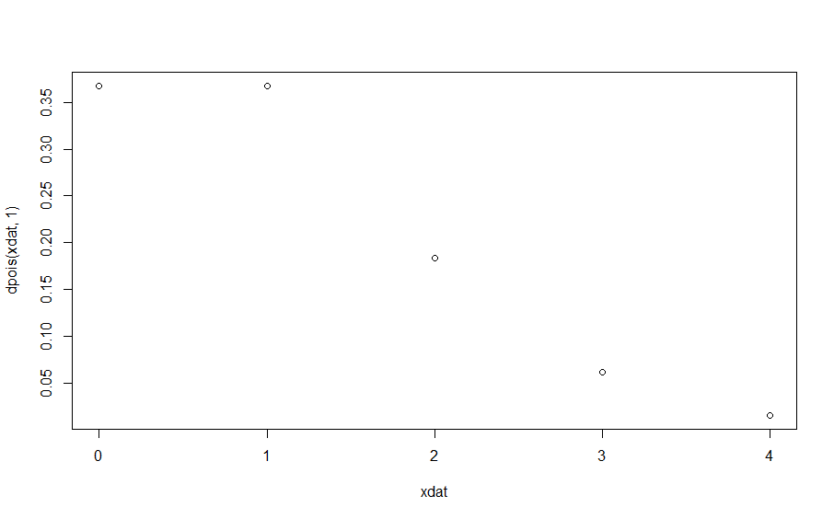d. p(x=0) = 0.36787944, this means that, when the true mean is 1, there is a 36% chance of having 0 deaths by horse kicking in a Prussian army.

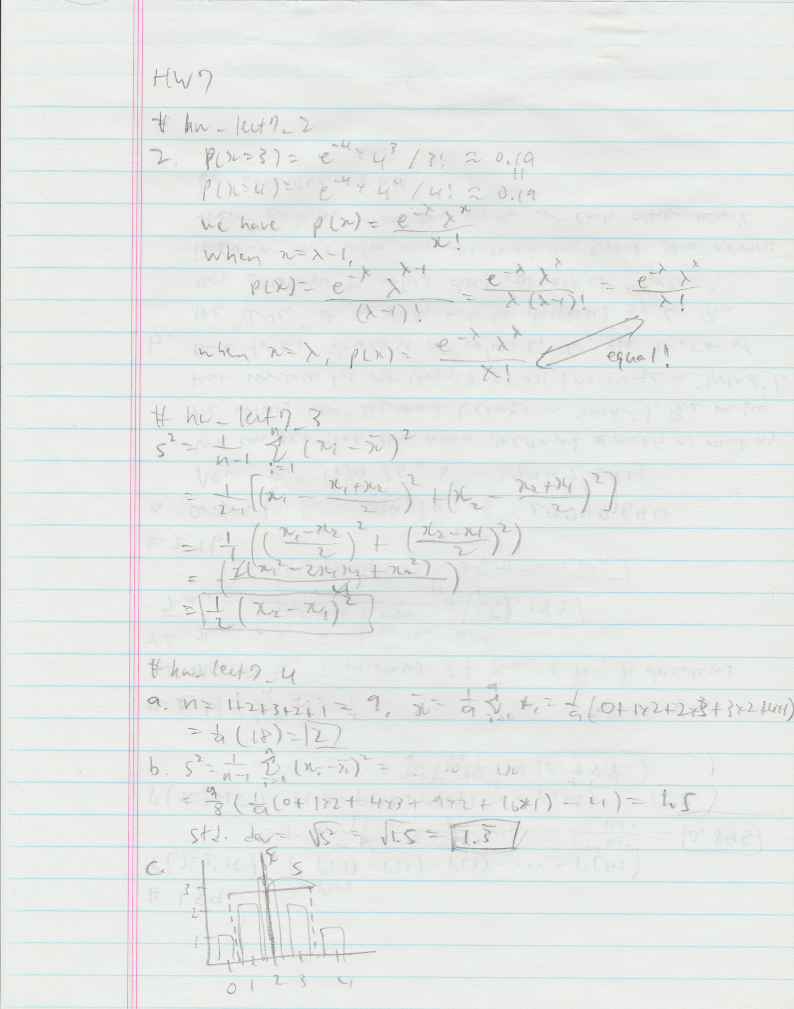

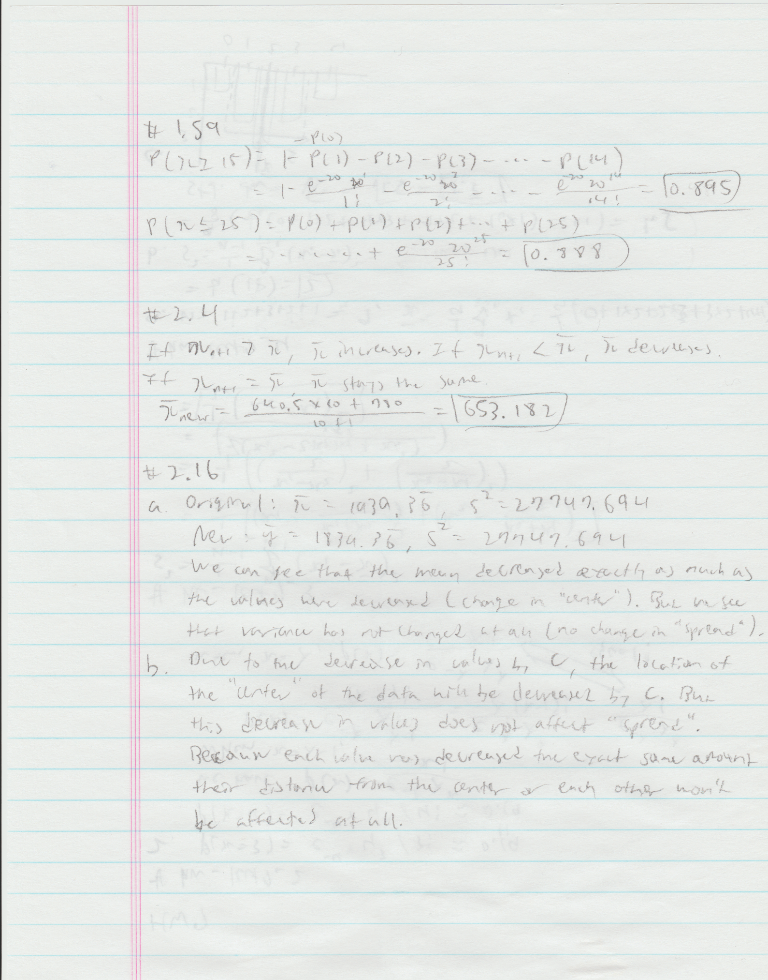

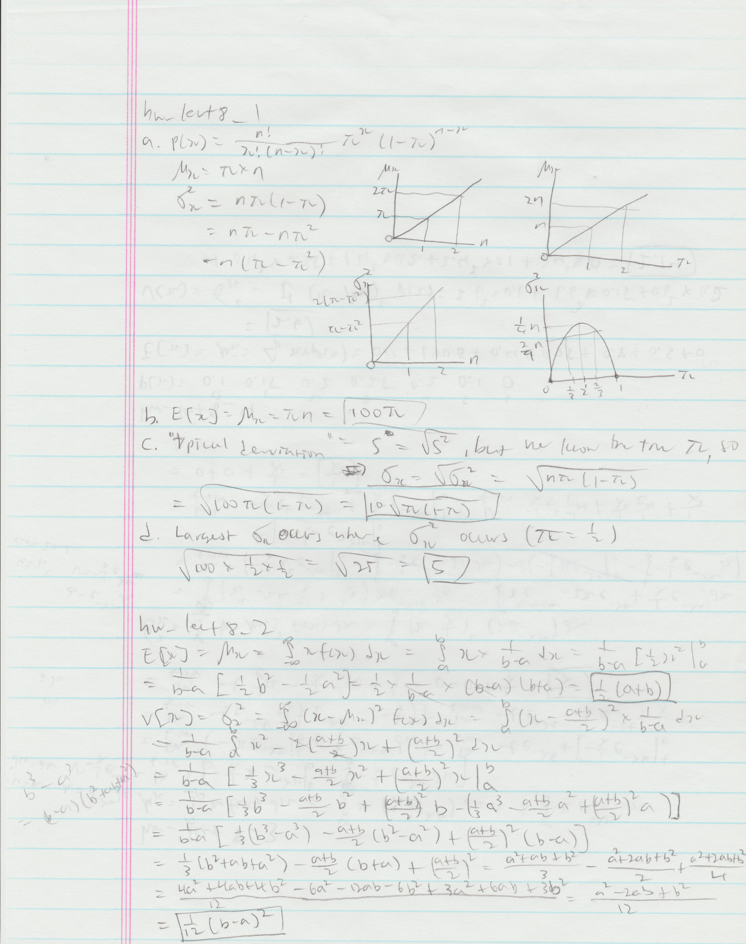

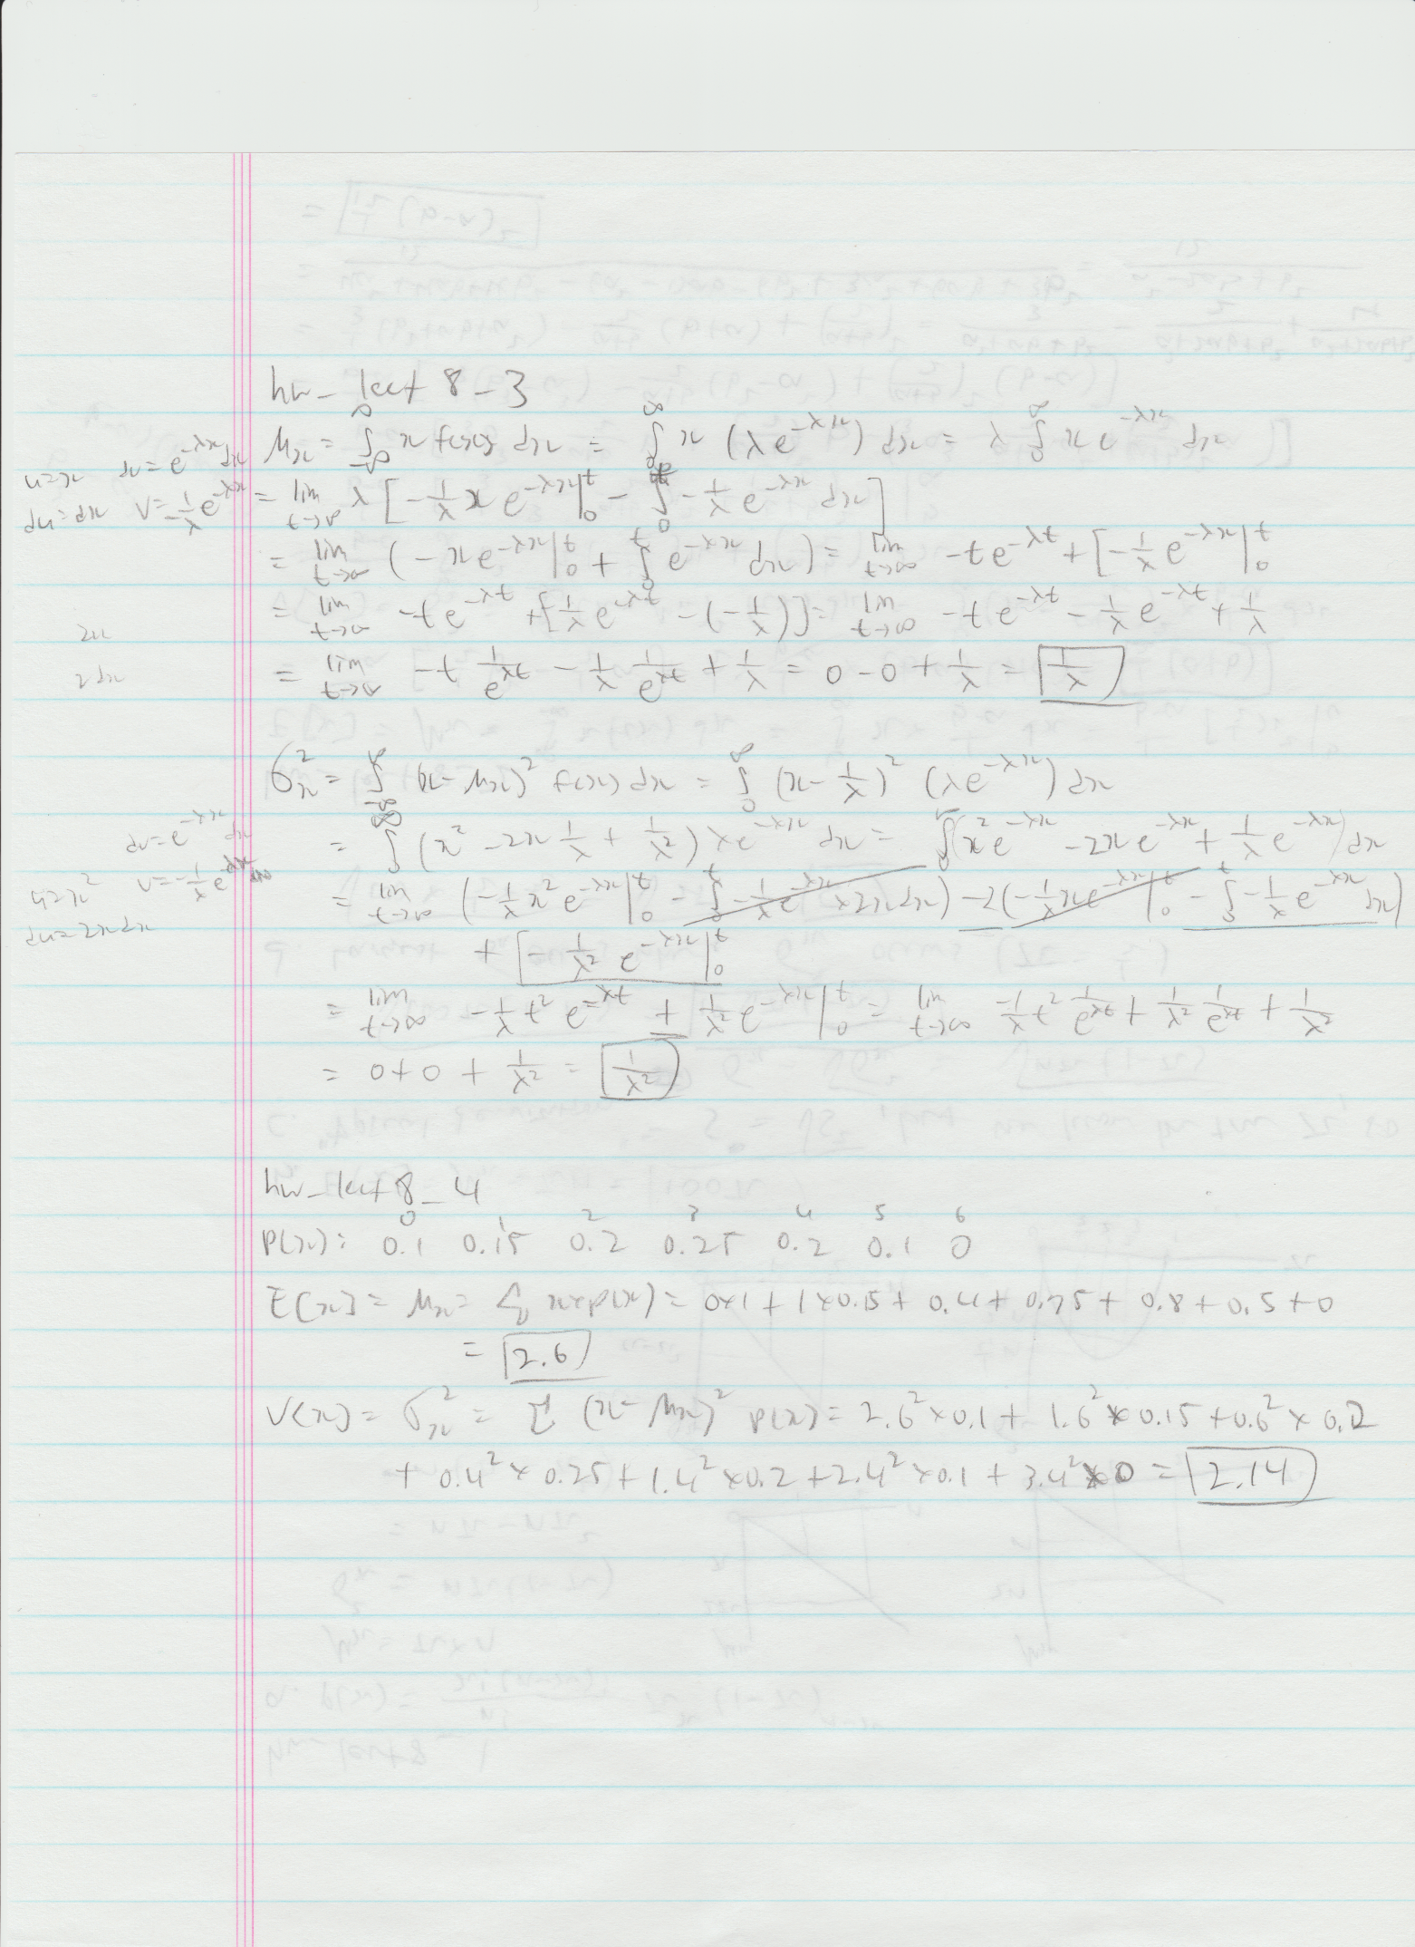

**# hw_lect8_5**

# get sample sizes

z = numeric(100)

# assign different sample sizes to different vars

for (i in 1:100) {

assign(paste("x_",i,sep = ""), rexp(i^2,1/2))

z[i] = i^2

}

# get means

x = numeric(100)

for (i in 1:100) {

x[i] = mean(get(paste("x_",i,sep = "")))

}

# get std devs

y = numeric(100)

for (i in 1:100) {

y[i] = sd(get(paste("x_",i,sep = "")))

}

# mean and std dev versus sample size

plot(x,z,col = "black")

points(y,z, col = "red")

graph below…

